Proceedings of the 1031st Regular weekly meeting of the club corresponding to the 22nd meeting of Rotary year 2014-14 of Rotary Club of Sher-e-Banglanagar, Dhaka held on 15th February 2014 at 6:30 PM at Rapport Bangladesh Seminar Hall, Dhaka.

Meeting Called to order :

Rtn. Farida Parveen, President, Rotary Club of Sher-e-Banglanagar, Dhaka hereby called 1031st regular weekly meeting to order. She welcomed everybody and requested them to join the singing of the national anthem in chorus led by herself.

Rotary Invocation :

Rtn. Badoruzzaman Chowdhury led the Rotary Invocation.

The following members were Present in the meeting on 15th February 2014

Sl.No. | Members Present | We missed the fellowship of following Rotarians
01 | Rtn. Dr. M. Mosharraf Hossain | 01
02 | Rtn. Farida Parveen | 02 | PP Rtn. Dr. Shariful Islam
03 | Rtn. Fariduddin Ahmmad | 03 | Rtn. Shibbir Ahmed Khan
04 | PP Rtn. M. A. Latif | 04 | PP Rtn. Dr. Abdus Sobhan
05 | Rtn. A B M Siddiq | 05 | IPP Rtn. M. Ali Hossain
06 | Rtn. Md. Nazim Uddin | 06 | PP Rtn. ABM Sharif Uddin
07 | Rtn. Bodoruzzaman Chowdhury | 07 | Rtn. Md. Sakhawat H. Bhuiyan
08 | Rtn. Shahinoor Rahman | 08 | PP Rtn. M. R. Khan
09 | PP Rtn. Tayebur Rahman
10 | Rtn. Asim Tarafder
11 | PP Rtn. Sukriti Mukherjee
12 | Rtn. Gofran Ahmed
13 | Rtn. Aahmed A Nabin

Felicitations:

This is the birthday of very dear PDG Rtn. Dr. M. Mosharraf Hossain. All the club members render wish him in different words, flowers, gifts. Everybody prays to the Almighty for his long live.

This day is also birthday of another club member Rtn. A B M Siddiq. Everybody also wises for him with a flower bouquet.

Everybody also wishes with a flower bouquet to the President Elect Rtn. Bodoruzzaman Chowdhury, whose birthday is was on 3rd February.

At the same time, the club members cordially wishes the First Gentleman of the Club (Spouse of Club president) . His birthday was on 13th February.

President’s Mail:
No President’s mail was in this week.

Make-up by:
There was no advance make-up by the Rotarian.

Member Guest:
No member guest was present.

Club Guest:

PP F H Arif, RC Dhaka and District Fellowship Chair
Rtn. Dr. M. Enamul Huq and his Spouse

Secretary’s Announcement:

The 1032nd regular weekly meeting of the club corresponding to the 23rd meeting of Rotary Year 2014-14 would be held on 22nd February, 2014 (Saturday) at 6:30 P.M. at RAPPORT Bangladesh Ltd., Dhaka.

Statistics of the Day:

Meeting No. 1031
Members on Roll 21
Members Present 08
Advance Make-up 00
Attendance Percentage 35%
Visiting Rotarians 00
Percentage of last meeting 50%

There being no other agenda the meeting was adjourned with a vote of thanks to the Chair.

Rtn. Farida Parveen Rtn. Shibbir Ahmed Khan
President Secretary
Rotary’s main objective is service - in the community, in the workplace, and around the globe. The 1.2 million Rotarians who make up more than 34,000 Rotary clubs in nearly every country in the world share a dedication to the ideal of Service Above Self.
Rotary clubs are open to people of all cultures and ethnicities and are not affiliated with any political or religious organizations.

Rotary International
The mission of The Rotary Foundation is to enable Rotarians to advance world understanding, goodwill, and peace through the improvement of health, the support of education, and the alleviation of poverty.
The Foundation is a not-for-profit corporation supported solely by voluntary contributions from Rotarians and friends of the Foundation who share its vision of a better world.

The Rotary Foundation
Photo gallery
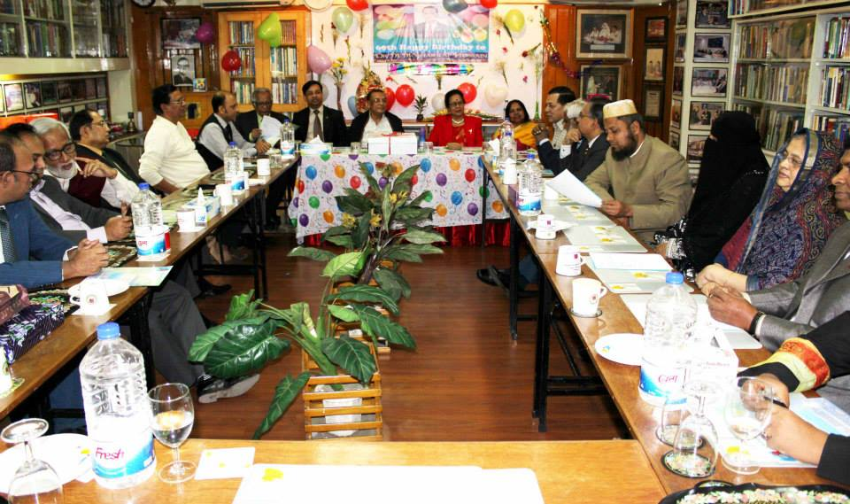

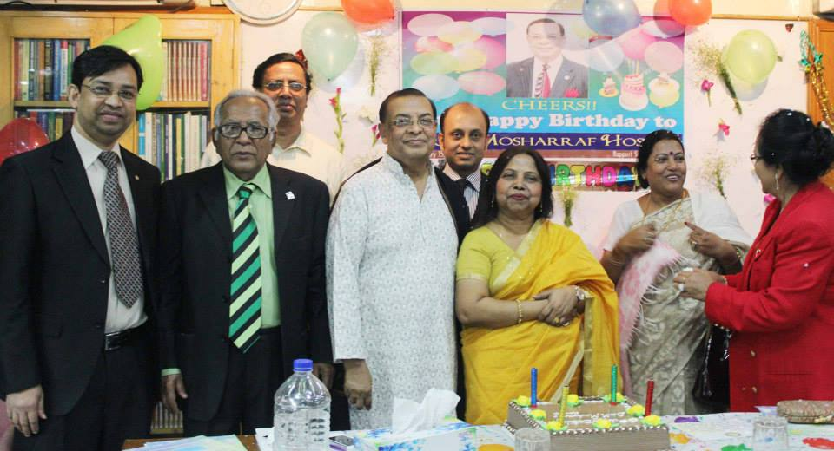
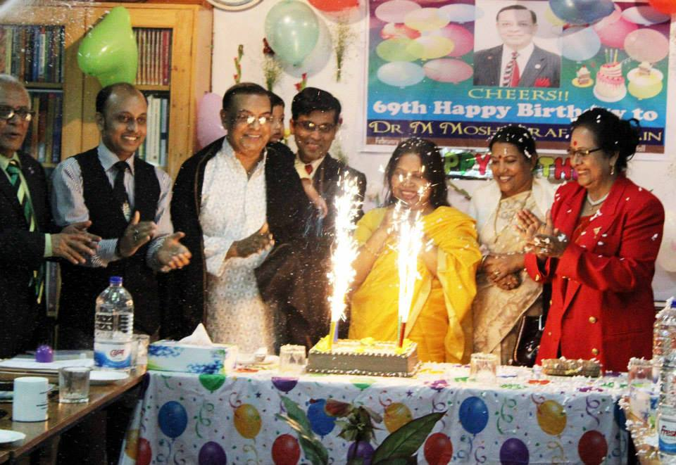

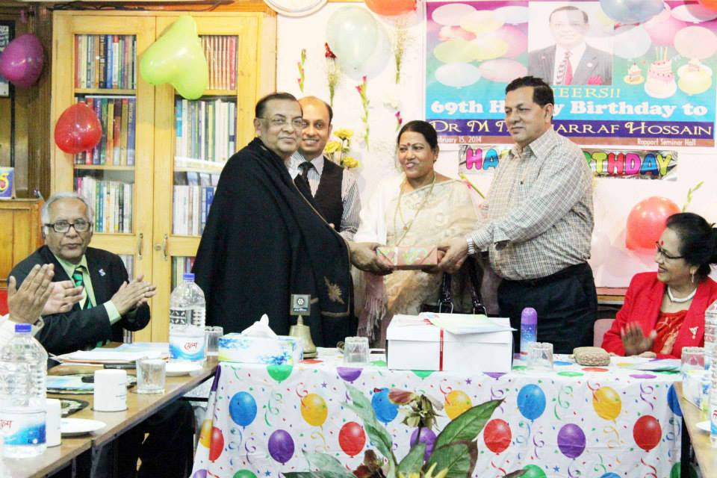
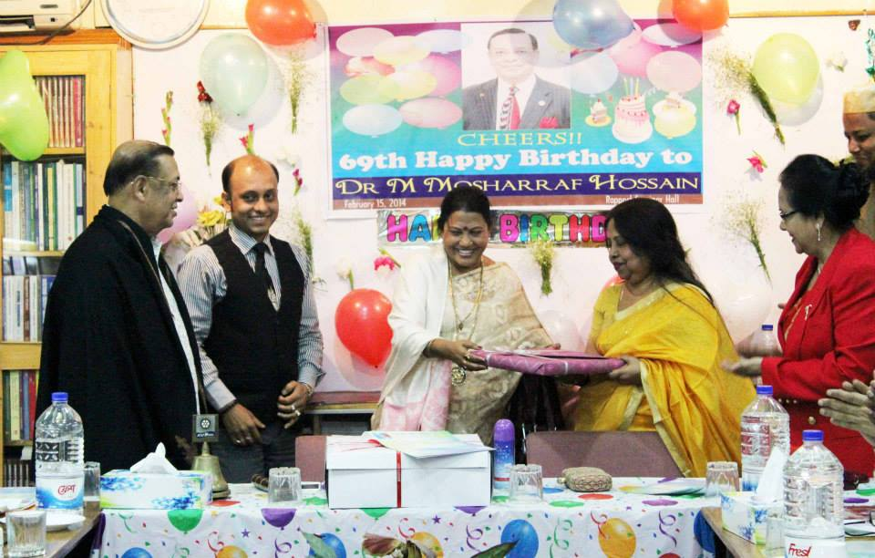

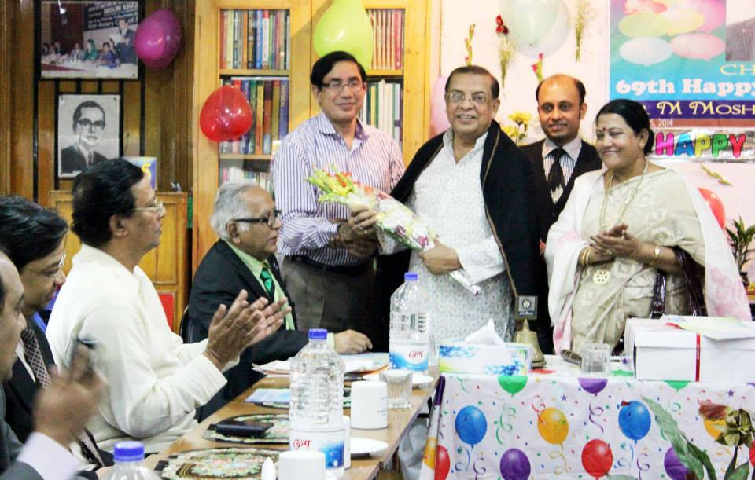
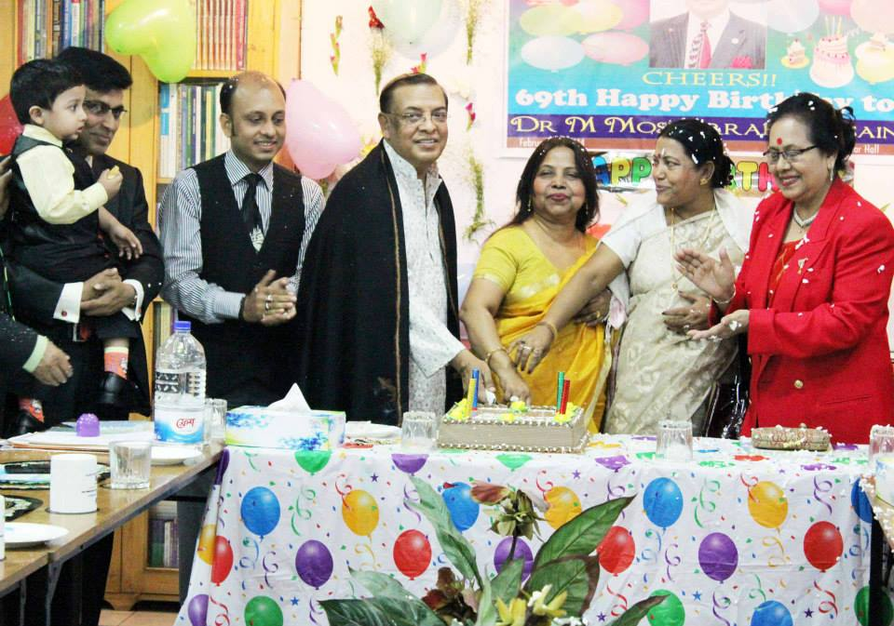

Sequences of the meeting and birthday party

