PROCEEDINGS OF THE 1010th REGULAR WEEKLY MEETING OF THE CLUB CORRESPONDING TO THE 1st MEETING OF ROTARY YEAR 2013-14 OF ROTARY CLUB OF SHER-E-BANGLANAGAR, DHAKA HELD ON 6th JULY, 2013 AT 7:00 P.M. AT RAPPORT BANGLADESH LTD. DHAKA.

Meeting Called to order :

Rtn. Farida Parveen, President, Rotary Club of Sher-e-Banglanagar, Dhaka hereby called 1010th regular weekly meeting to order. He welcomed everybody and requested them to join the singing of the national anthem in chorus led by Rtn. Farida Parveen.

Rotary Invocation :

PP Rtn. Dr. Abdus Sobhan led the Rotary Invocation.

The following members were Present/Absent in the meeting on 6th July, 2013
Sl.No. | Members Present : | Sl.No. | Members Absent :
01. | Rtn. Dr. M. Mosharraf Hossain | 01. | Rtn. Anisur Rahman
02. | Rtn. M. Ali Hossain | 02. | PP Rtn. Dr. Shariful Islam
03. | Rtn. Farida Parveen | 03. | PP Rtn. M. A. Latif
04. | Rtn. Asim Tarafder | 04. | Rtn. Gofran Ahmed
05. | Rtn. Fariduddin Ahmmad | 05. | Rtn. A B M Siddiq
06. | Rtn. Shahinoor Rahman | 06. | PP Rtn. Tayebur Rahman
07. | PP Rtn. M. R. Khan | 07. | Rtn. Farjahan Rahman
08. | PP Rtn. Sukriti Mukherjee | 08. | Rtn. Md. Nazim Uddin
09. | PP Rtn. ABM Sharif Uddin | 09. | Rtn. Shibbir Ahmed Khan
10. | PP Rtn. Dr. Abdus Sobhan
11. | Rtn. Bodoruzzaman Chowdhury
 | Percentage of Absent 45%

Felicitations :

1. Rtn. M. Ali Hossain BD 30th June
2. Rtn. Asim Tarafder Anniversary 5th July

President’s Mail :

No President’s mail was in this week.

Make-up by :

There was no advance make-up by the Rotarian.

Member Guest :

Mr. Aahmed A. Nobin Guest of Rtn. Farida Parveen
Mr. Anowar Hossain Guest of Rtn. Fariduddin Ahammad
Day’s Program :

The meeting started as per Agenda after detail discussion in the meeting the following agenda were discussed and adopted:

- What is Rotary ?
Club President Rtn. Farida Parveen requested PDG Rtn. Dr. M. Mosharraf Hossain to explain the meeting regarding What is Rotary ?. He took the microphone and narrated that it is a oldest humanitarian organization circulated around 170 countries in the world. Rotary was established in 1905 by four gentlemen belonging to different faiths, different profession and different nationalities in Chicago, USA. Now 1.2 million elite members are involved with the Rotary activities all over the world.

- Polio Eradication :

PDG Rtn. Dr. M. Mosharraf Hossain informed the meeting that Polio Eradication was one of the significant task of Rotary. The Polio Eradication movement was started in 1986, now the world is Polio free which is Rotary’s achievement. He also added that recently Rtn. Bill Gates has donated 435 million dollar to Rotary International for Eradication Polio from the Wrold.

- Discussion on Regular Weekly Meeting in Holly Ramadan :

It was decided in the meeting that in Holly Ramadan 3-4 meetings will be held. Rtn. Farida Parveen and Rtn. Shibbir Ahmed Khan will be the host of the 1st meeting and other host will be confirmed in our next regular weekly meeting.

Secretary’s Announcement :

In absence of Secretary Rtn. Shibbir Ahmed Khan, IPP Rtn. Ali Hossain conducting the club business and announced that :

The 1011th regular weekly meeting of the club corresponding to the 2nd meeting of Rotary Year 2013-14 would be held on 13th July, 2013 (Saturday) at 7:00 P.M. at RAPPORT Bangladesh Ltd., Dhaka.

Statistics of the Day :
Club Statistics was given by Rtn. Fariduddin Ahammad

Meeting No. 1010
Members on Roll 20
Members Present 11
Advance Make-up 00
Attendance Percentage 55%
Visiting Rotarians 00
Percentage of last meeting 55%

1st Comer of the Meeting : 1st comer of the meeting IPP Rtn. Ali Hossain

There being no other agenda the meeting was adjourned with a vote of thanks to the Chair.

Rtn. Farida Parveen IPP Rtn. Ali Hossain
President Acting Secretary
Photo gallery
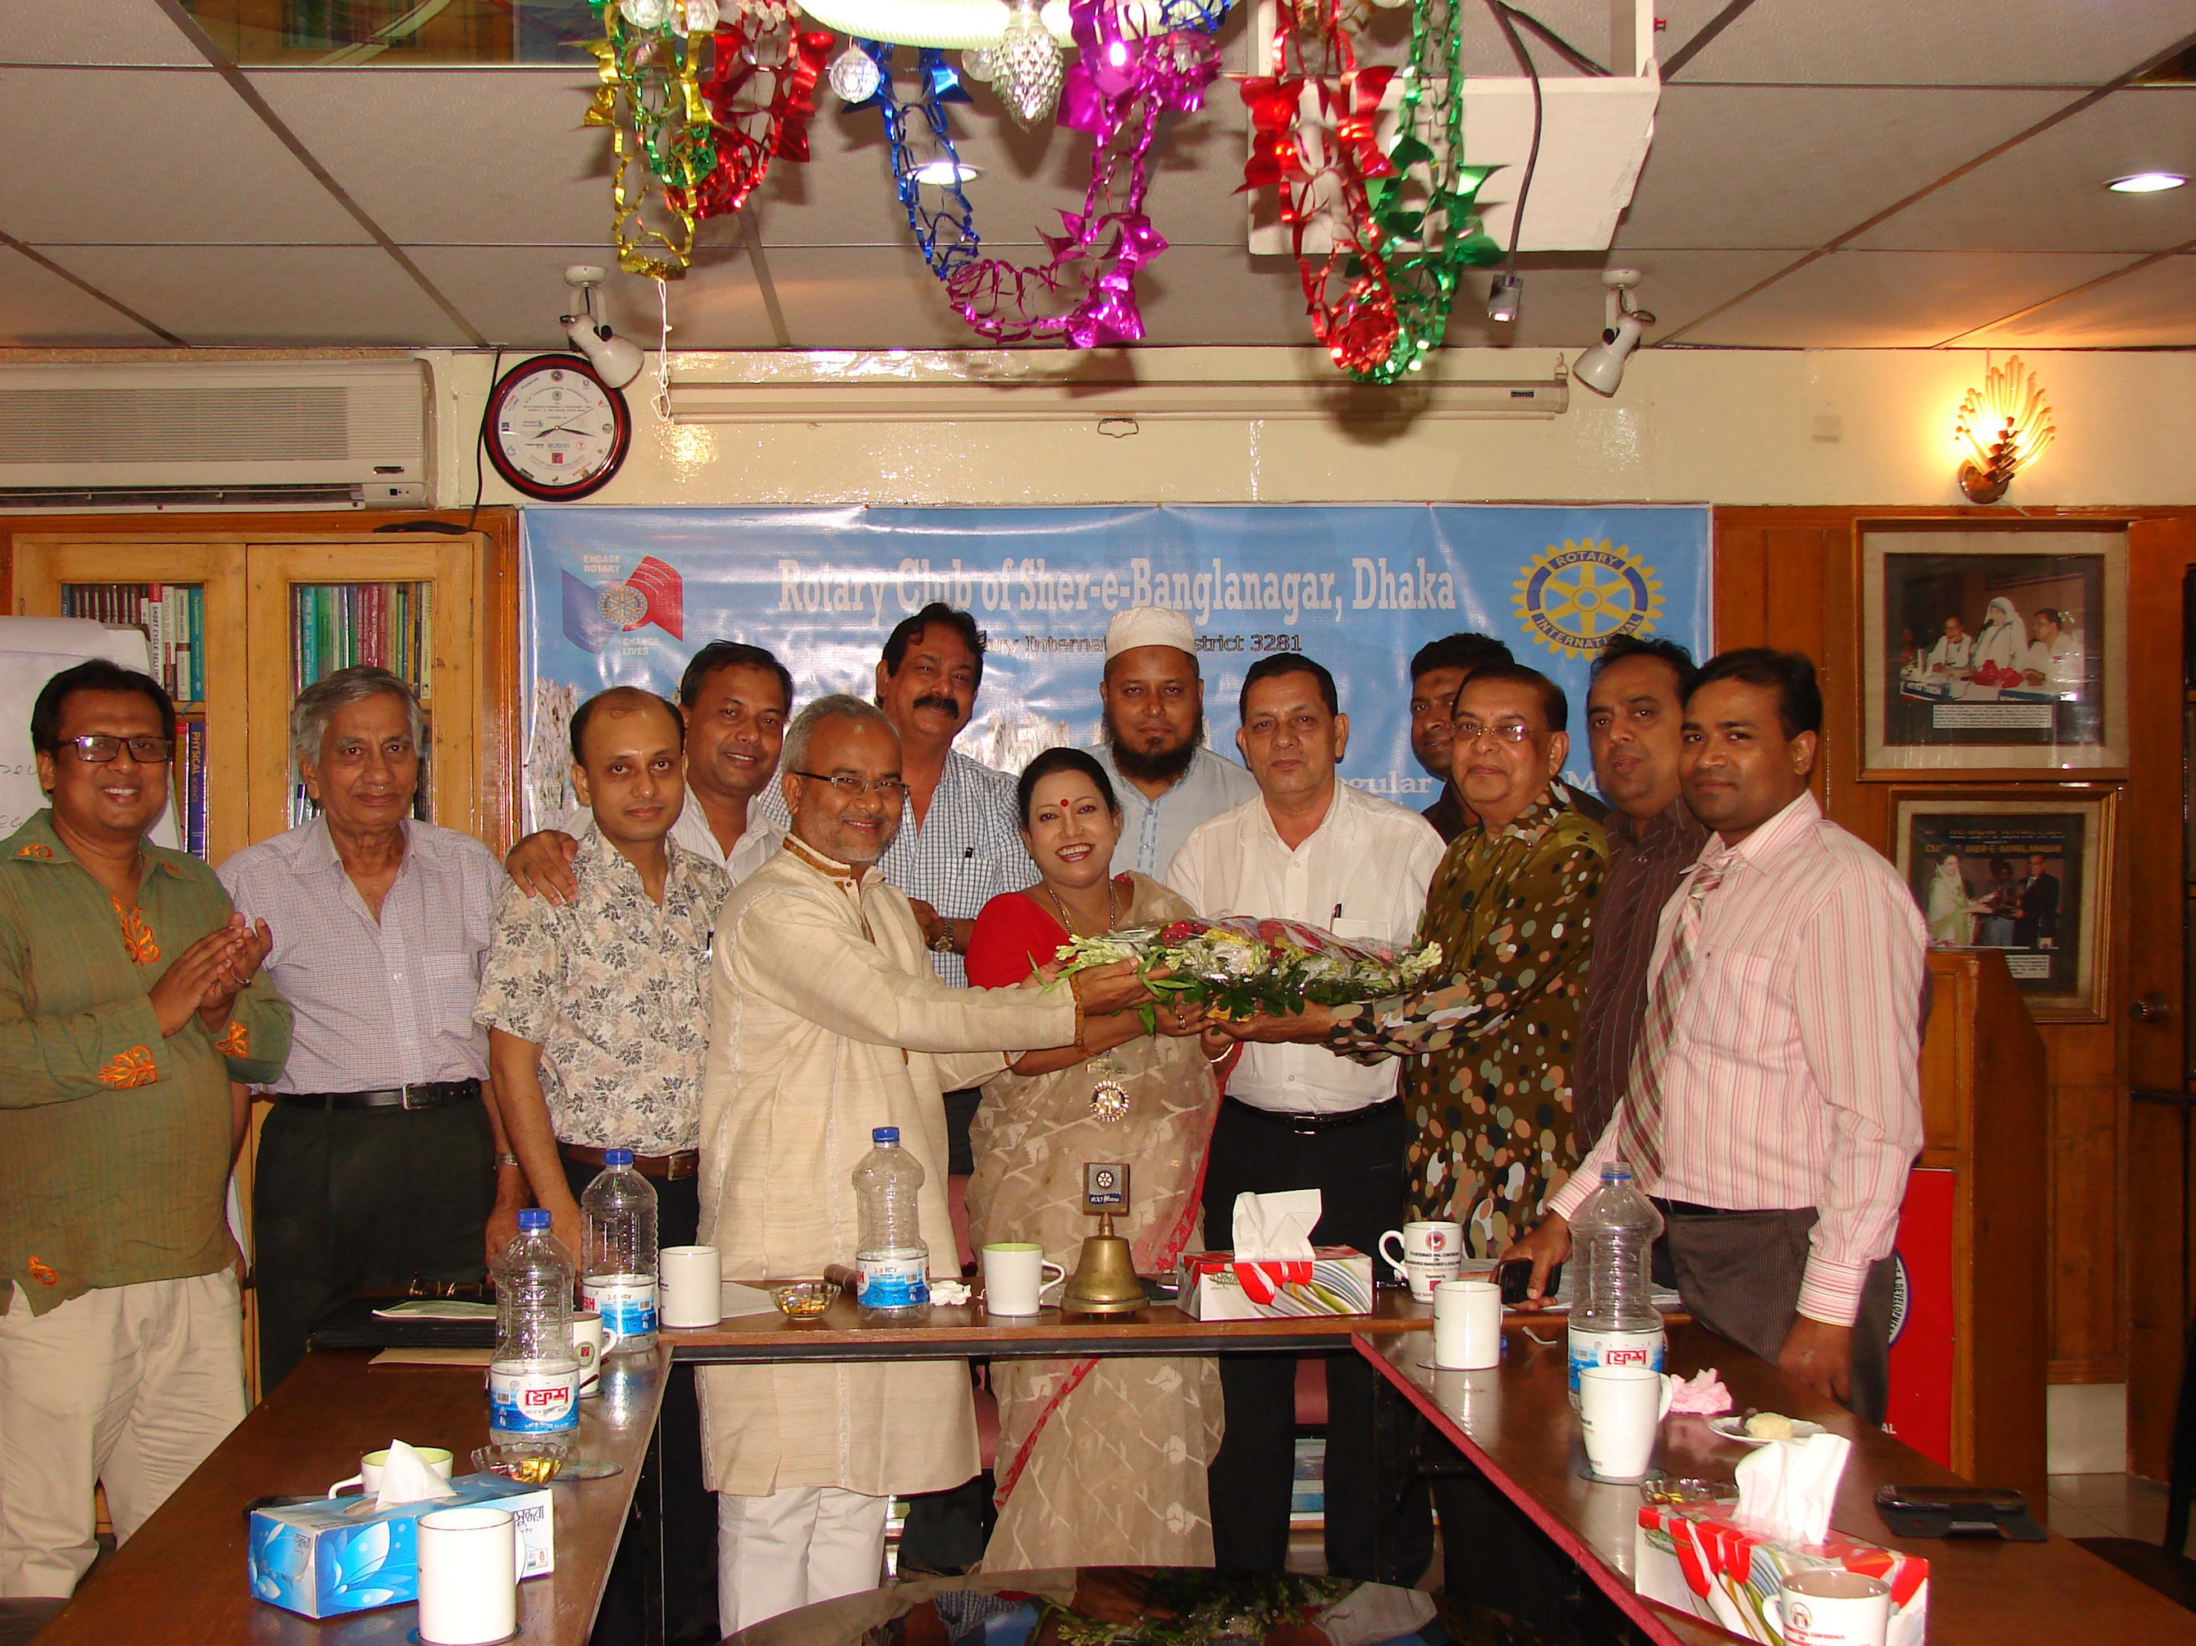

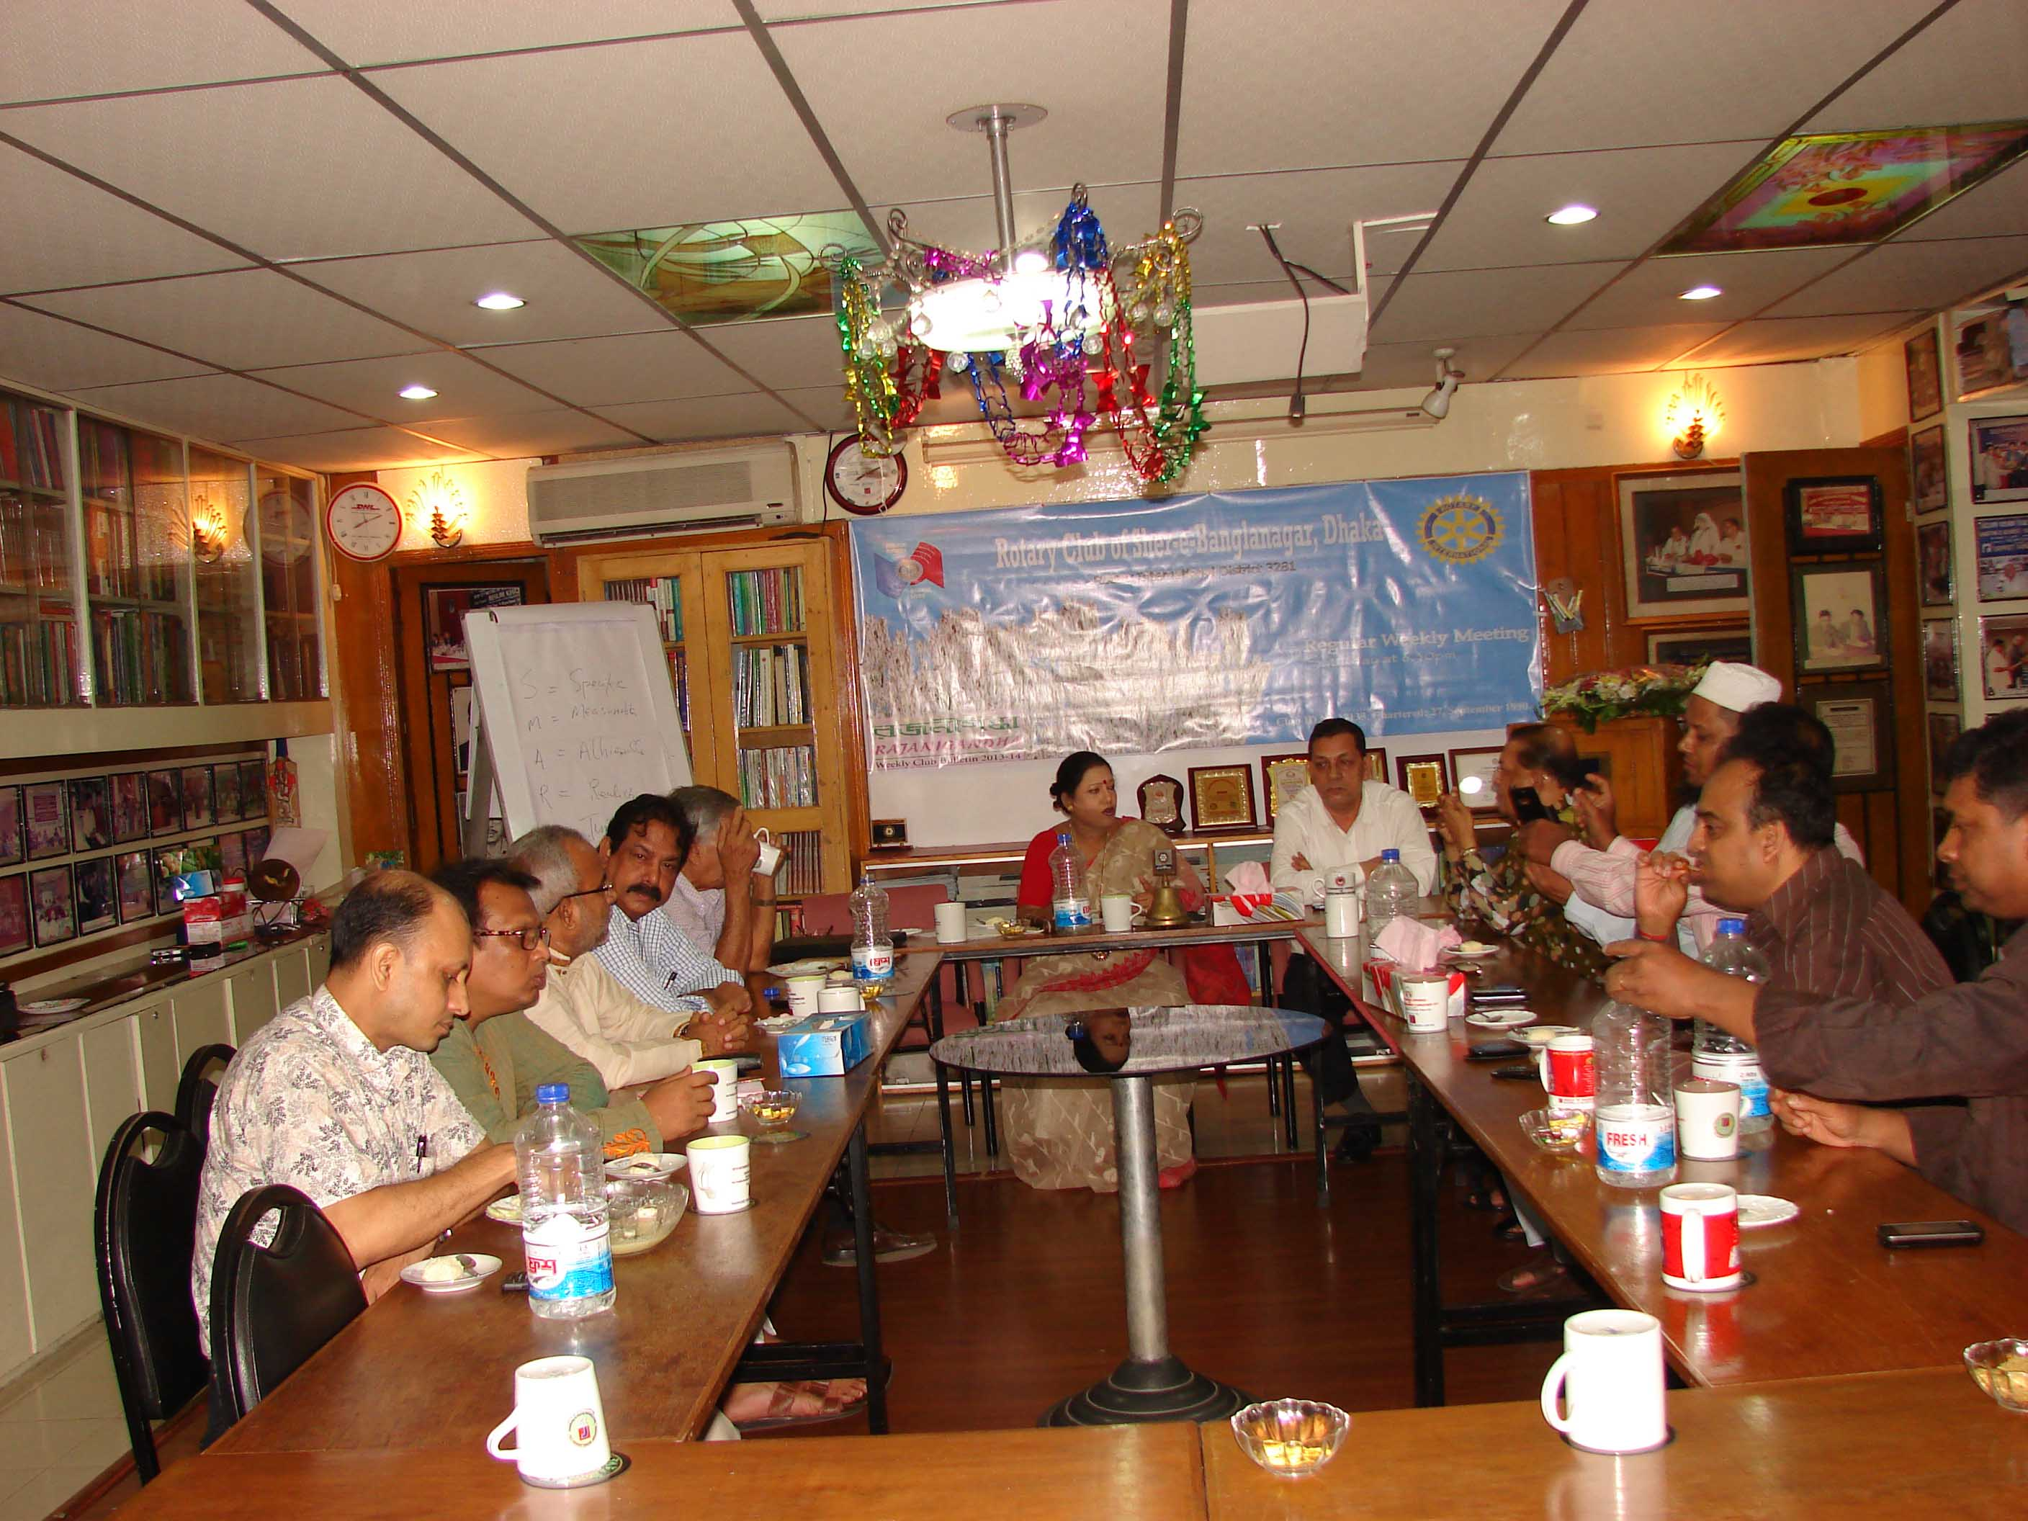
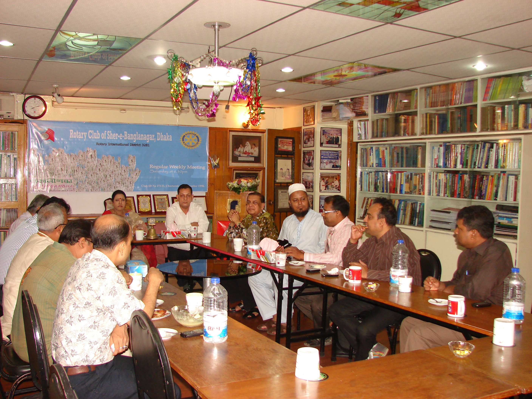
Club members are welcoming the new president with a flower bouquet
Sequences of the meeting

Rotary’s main objective is service - in the community, in the workplace, and around the globe. The 1.2 million Rotarians who make up more than 34,000 Rotary clubs in nearly every country in the world share a dedication to the ideal of Service Above Self.
Rotary clubs are open to people of all cultures and ethnicities and are not affiliated with any political or religious organizations.

Rotary International

The Rotary Foundation
The mission of The Rotary Foundation is to enable Rotarians to advance world understanding, goodwill, and peace through the improvement of health, the support of education, and the alleviation of poverty.
The Foundation is a not-for-profit corporation supported solely by voluntary contributions from Rotarians and friends of the Foundation who share its vision of a better world.

